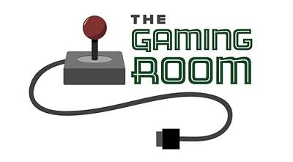

Draw It or Lose It

CS 230 Project Software Design
Version 1.0

Table of Contents

CS 230 Project Software Design 1
Table of Contents 2
Document Revision History 2
Executive Summary 3
Requirements 3
Design Constraints 3
System Architecture View 3
Domain Model 3
Evaluation 4
Recommendations 6

Document Revision History

Version | Date | Author | Comments
1.0  3.0 | 1/25/2024  2/25/2024 | Zaffar Shiekh  Zaffar Shiekh | In this revision of the software design document for "Draw It or Lose It," I have elaborated on the game's core requirements and proposed a comprehensive system architecture suited for multi-platform compatibility. Key elements such as unique team/player identification, client-server interaction, and a scalable, secure infrastructure are detailed. The document aligns with The Gaming Room’s objectives, ensuring a robust, user-friendly, and cross-platform web-based game.  The enhancements made to your software design document for The Gaming Room focus on ensuring scalability, flexibility, and security across diverse computing environments. We've recommended Windows as the operating platform, emphasizing its cloud deployment capabilities via Azure for scalable and flexible game management. The document now details the architecture of Windows Server and Azure, highlighting their integration and management features for distributed systems. We've also expanded on storage and memory management systems compatible with Windows, incorporating techniques that optimize game performance. Additionally, security measures to protect user information on various platforms have been elaborated, ensuring a comprehensive approach to user data safety and system integrity in distributed networks.

Executive Summary

Creative Technology Solutions is embarking on a project to transform The Gaming Room's "Draw It or Lose It," currently an Android-exclusive game, into a versatile web-based application. Our goal is to create a game that accommodates multiple teams, each with numerous players, while ensuring uniqueness in game and team names and maintaining a single game instance in memory. The solution proposes a cross-platform application adaptable to various environments including Android, iOS, Windows, Linux, and Mac. Critical to our approach is the use of design patterns and software best practices to meet these requirements.

Requirements

The project presents several design constraints:
- Cross-Platform Compatibility: The game must function seamlessly across different operating systems and devices.
- Unique Identifiers: Game and team names must be unique, necessitating a robust validation mechanism.
- Single Instance in Memory: To avoid data conflicts, only one instance of the game should exist at any given time.
- Scalability and Performance: The application must be scalable to handle multiple teams and players without performance degradation.

Design Constraints

- Cross-Platform Compatibility:
  - Uniform Experience Across Devices: The game must provide a consistent user interface and gameplay experience on various platforms, including desktop and mobile devices.
  - Responsive Design: Implementation of a responsive design to ensure the game adjusts seamlessly to different screen sizes and resolutions.
  - Technology Stack: Use of cross-platform development frameworks (like Unity or Xamarin) to enable code reusability and maintain uniformity across different operating systems.
- Unique Identifiers:
  - Validation Mechanism: Implement a robust validation system to ensure each game and team name is unique, preventing duplication and confusion.
  - Database Checks: Real-time checks against a central database when a user attempts to create a new game or team, to verify the uniqueness of the names.
  - User Feedback: Provide immediate feedback to users if the chosen name is already in use, along with suggestions for available names.
- Single Instance in Memory:
  - Singleton Design Pattern: Utilize the Singleton design pattern to ensure that only one instance of the game logic exists in memory at any time, preventing conflicts and inconsistencies.
  - Memory Management: Efficient memory management to ensure that the single instance does not lead to memory leaks or performance issues.
  - State Management: Implement state management strategies to maintain game state consistency across different client sessions.
- Scalability and Performance:
  - Load Balancing: Implement load balancing to distribute user requests efficiently across servers, especially during peak usage times.
  - Efficient Data Handling: Optimize database queries and data handling to minimize latency and maximize performance.
  - Scalable Architecture: Design the backend to be scalable, possibly using microservices architecture, to easily handle an increasing number of players and teams.

System Architecture View

We propose a modular client-server architecture. The backend will be responsible for game logic and data management, likely using technologies like Java Spring Boot for its robustness and scalability. The frontend, developed with React or Angular, will ensure a dynamic user experience. Mobile compatibility will be achieved using React Native or Flutter.

Domain Model

The UML diagram illustrates a well-structured hierarchy:
- Entity Class: Serves as the superclass, providing common attributes like id and name.
- Game Class: Inherits from Entity, manages game instances.
- Team Class: Subclass of Entity, handles team-related data.
- Player Class: Another subclass of Entity, represents individual players. This model employs object-oriented principles like inheritance and encapsulation, promoting code reusability and scalability.

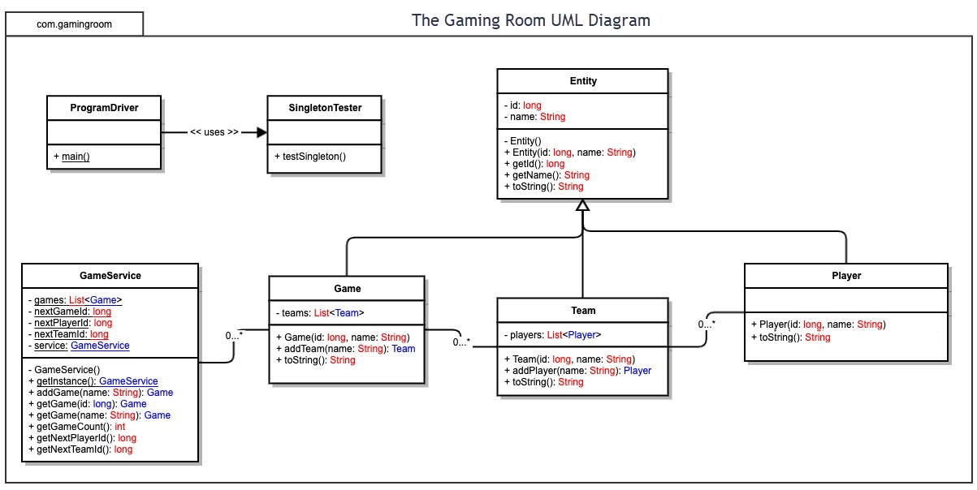

Evaluation

Development Requirements | Mac | Linux | Windows | Mobile Devices
Server Side | Known for its robust terminal and popularity in web hosting, Mac offers upgradeable options with various web hosting requirements. However, it is less preferred due to the higher cost compared to Linux. | Preferred for its security and cost-effectiveness. It's a secure platform, with most vulnerabilities identified and resolved swiftly. However, it may lack specific application support. | Dominant in software availability with a closed platform architecture. It offers high resource efficiency but is more susceptible to viruses. | Ideal for portability and reach but selective in compatibility and has weaker security compared to desktop operating systems.
Client Side | Each requires varying levels of expertise and cost, with Windows and Mac being more user-friendly but potentially costlier than Linux. | Each requires varying levels of expertise and cost, with Windows and Mac being more user-friendly but potentially costlier than Linux. | Each requires varying levels of expertise and cost, with Windows and Mac being more user-friendly but potentially costlier than Linux. | Offer flexibility but require a nuanced approach in development for compatibility and performance.
Development Tools | Support a wide range of languages and IDEs, including Java, Python, PHP, Ruby, and tools like Visual Studio and Eclipse. | Support a wide range of languages and IDEs, including Java, Python, PHP, Ruby, and tools like Visual Studio and Eclipse. | Support a wide range of languages and IDEs, including Java, Python, PHP, Ruby, and tools like Visual Studio and Eclipse. | Focus on Android and Swift for development, which is compatible across different platforms.

Recommendations

- Operating Platform: Windows
We recommend Windows due to its extensive software support and developer familiarity. It offers:
  - Broad Compatibility: Windows supports a wide range of development tools and libraries, crucial for a multi-platform game like "Draw It or Lose It."
  - Rich Development Environment: Tools like Visual Studio provide a robust environment for developing, debugging, and testing applications.
  - Large Developer Community: A vast community of Windows developers can provide support, plugins, and extensions that can be crucial in solving complex development challenges.
- While Windows offers extensive software support and a familiar environment for developers, incorporating a multi-platform approach through the use of cloud-based solutions or a Linux-based server could enhance compatibility and scalability. These platforms provide robust security features, necessary for a game expanding into various computing environments.

- Operating Systems Architectures: Windows-Based GUI
The Windows-based GUI architecture is chosen for its:
  - User-Friendly Interface: Familiar to a broad audience, enhancing user engagement.
  - Resource Management: Efficient handling of system resources, which is vital for a graphic-intensive game.
  - Accessibility: Windows GUI supports various accessibility features, making the game more inclusive.
- The Windows-based GUI architecture is indeed user-friendly and resource-efficient. However, considering a cross-platform framework like .NET Core could offer similar benefits while also ensuring the game's operability across different operating systems, further broadening its reach.

- Storage Management: Windows 10's Storage Sense
Windows 10's Storage Sense offers:
  - Automated Cleaning: Regularly clears temporary files and unused applications, ensuring efficient storage management.
  - Customization: Allows for personalized settings for how often to clean and what to clean, aiding in effectively managing the game's data storage.
  - Cloud Integration: Seamlessly integrates with cloud storage solutions like OneDrive, offering additional storage and backup options.
- Windows 10's Storage Sense is a solid choice for automated cleaning and customization. Augmenting this with cloud storage solutions not only for backup but also for game state synchronization across devices can offer a seamless gaming experience.

- Memory Management: Effective Allocation
Effective memory management for an extensive library of images includes:
  - Dynamic Memory Allocation: This function dynamically allocates memory as needed for new images, ensuring efficient use of system resources.
  - Caching Strategies: Implements caching to quickly load frequently accessed images, enhancing game performance.
  - Memory Leak Prevention: Regular checks and updates to ensure no memory leaks, which could degrade game performance over time.
- Dynamic memory allocation and caching strategies are crucial. Integrating these with modern garbage collection techniques could optimize memory usage, which is especially important in a graphic-intensive game to maintain performance across all platforms.

- Distributed Systems and Networks: Cross-Platform Tools
Using cross-platform development tools like Develop Four allows for:
  - Consistent User Experience: Ensures the game looks and feels the same across different platforms.
  - Rapid Development and Deployment: Facilitates quicker development cycles and easier deployment across different operating systems.
  - Scalability: Supports scaling the application to accommodate increasing users and data.
- Leveraging cross-platform development tools is a step in the right direction. Enhancing this by adopting microservices architecture could facilitate better scalability and manageability, especially as the game grows in popularity and complexity.

- Security: Enhanced Measures
Robust security measures involve:
        - Data Encryption: Using advanced encryption standards, encrypt sensitive user data at rest and in transit.
        - Regular Security Updates: Ensuring the game's software is regularly updated to protect against new vulnerabilities.
        - Authentication and Authorization: Implementing robust user authentication methods and proper authorization checks to prevent unauthorized access.
- While data encryption and regular updates are foundational, incorporating comprehensive application security practices, including secure coding practices, threat modeling, and regular penetration testing, can further fortify the game against emerging security threats.

